April 20, 2017 *(date)*

Thank you for attending the Public Information Open House for the proposed diverging diamond interchange (DDI) at Interstate 185 (I-185) and Buena Vista Road, PI Number 0012577. Our goal is two-fold: 1) to provide you with information on the proposed project and 2) to provide an opportunity for you to give us your comments on the proposed project. In this handout package, you will find a description of the project, a location map, and a comment card.

As you enter the room, please take a look at the project display. Georgia Department of Transportation (Georgia DOT) representatives, wearing nametags, are available to discuss the project and answer your questions. There will be no formal presentation.

We hope you will take the opportunity to tell Georgia DOT what you think. Listed below are several ways to comment on the project. Your comments are important to us and, should you provide comments by one of the methods noted below, we will respond to you in writing usually within 30 days of the close of the comment period. All comments will become part of the project’s official record.

While you are attending the open house, you can **provide your comments today** by filling out the comment card provided with this handout and dropping it in the comment box, or you may choose to provide your verbal comments to the court reporter who will transcribe your comments.

You can also **provide your comments by** Thursday, May 04, 2017 by using any of the following methods:

* Email your comment to [TIAComments@dot.ga.gov](mailto:TIAComments@dot.ga.gov)
* Online at: [https://goo.gl/ahNMv2](https://urldefense.proofpoint.com/v2/url?u=https-3A__goo.gl_ahNMv2&d=DwMF-g&c=cUkzcZGZt-E3UgRE832-4A&r=wNsBOzU-h_mella1WSsQ2Pa1JtaCSEBaVEbi76XCk3FWo3-3vz-bifaCLEjIi6UF&m=CiJnn4OcWaaq0ZihyggG4s2AQ2e83bugnSrJwZWkdGE&s=s4cILBhWY7Bi_UlUARZ82m7Vvw9A3AHbZe2zGciyVSg&e=)
* Mail in your comment card to Mr. Kelvin Mullins, Georgia Department of Transportation, 600 West Peachtree Street NW, 19th Floor, Atlanta, Georgia 30308.

Project materials can also be viewed after the PIOH meeting by visiting [http://ga-tia.com/Home/News](https://urldefense.proofpoint.com/v2/url?u=http-3A__ga-2Dtia.com_Home_News&d=DwMF-g&c=cUkzcZGZt-E3UgRE832-4A&r=wNsBOzU-h_mella1WSsQ2Pa1JtaCSEBaVEbi76XCk3FWo3-3vz-bifaCLEjIi6UF&m=CiJnn4OcWaaq0ZihyggG4s2AQ2e83bugnSrJwZWkdGE&s=sUXop4h-cebCKb5wUQxFNYWj7sUJKPthonPa1daknQ0&e=), clicking the Public Notice tab at the bottom of the page, and then selecting the project name.

The project displays and plans will be available for review for ten days after this open house at the website noted above. Hardcopies will also be available at the Columbus Consolidated Government Planning Department *(be sure to verify the correct office location with the District Office, Design Office or by checking the ad)* located at 420 10th Street, Columbus, Georgia, 31901. Following the ten-day public comment period, a copy of all comments received will be available by request at the Atlanta address listed above.

Again, thank you for attending this open house. If you should have any questions or need additional information, feel free to contact the project manager, Nona Guilford, at (404) 631-1193 or the environmental analyst, Laura Dawood, *NEPA planner*at (770) 548-9904.

Sincerely,

Kelvin Mullins

State TIA Administrator

Georgia Department of Transportation

**Why We Are Here:** The proposed project would benefit the traveling public by alleviating the congestion at and along Buena Vista Road, and improve operational efficiency and provide improved access to Interstate 185 (I-185). The improvements in operational efficiency could also potentially decrease the frequency and severity of crash incidents and provide a smoother surface for travel.

**Project Description:** The proposed project would replace the existing I-185 interchange at Buena Vista Road with a diverging diamond interchange (DDI). Sidewalk and multi‐use path would also be constructed along Buena Vista Road at the approaches to the bridge over I‐185 and be provided in the center median area of the DDI. The project limits are approximately between Steam Mill Road and Rosewood Drive along Buena Vista Road, a distance of approximately 1.04 miles; and would be contained within the existing northbound and southbound entrance and exit ramps along I-185. Existing right-of-way (ROW) varies between 75 feet and 115 feet along Buena Vista Road. Proposed ROW for the interchange would be the widest at the interchange approaches, varying between approximately 90 feet to 180 feet. Required ROW along Buena Vista Road would vary to a width of approximately 90 feet.

Project Location Map:

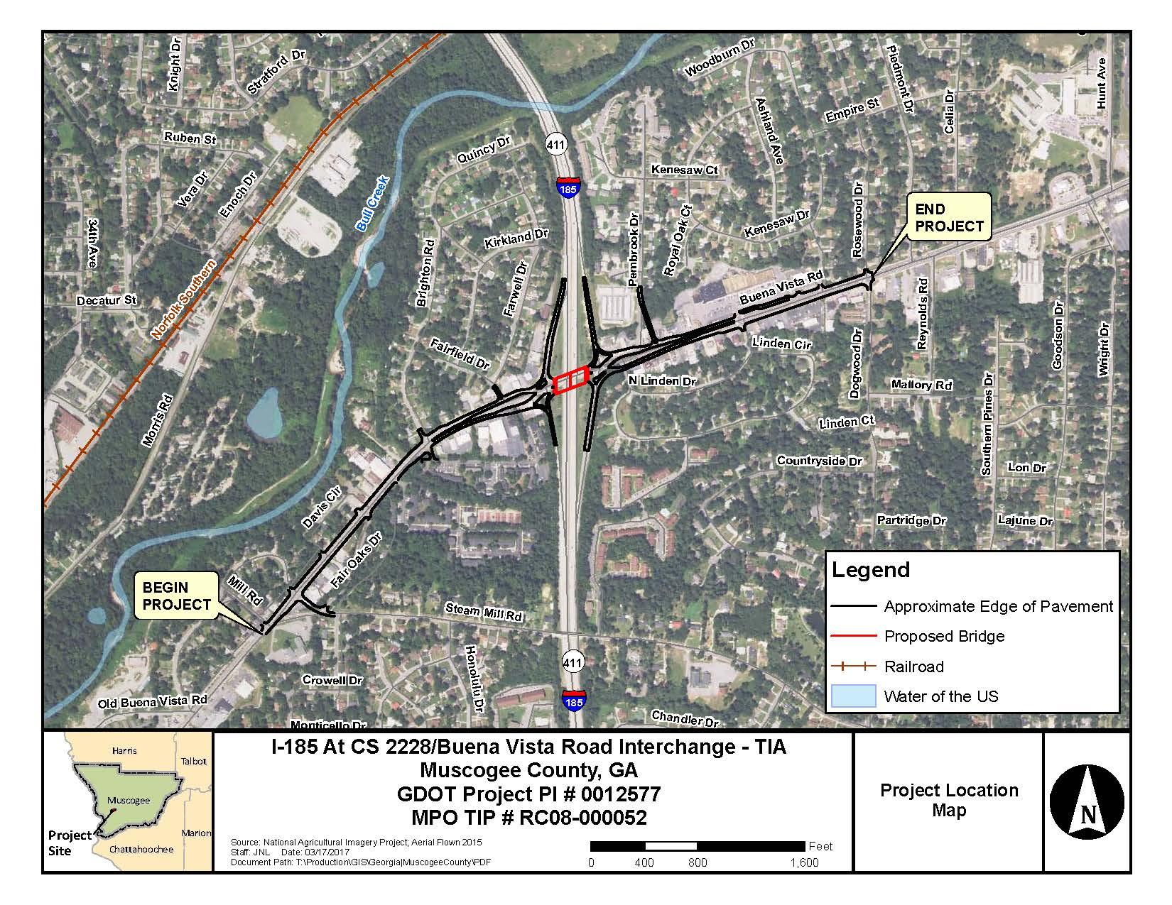

**Comment Card**

# *Please print responses.*

Name

Address

Do you support the projectChoose an item. (check your response)

***□ For □ Against □ Conditional □ Uncommitted***

General Comments

How did you hear about this Open House? (check) ***□ Newspaper □ Signs □ GDOT Website □ Radio***

***□ Word of Mouth □ Social Media □ Other***

Was the location of the Open House convenient for you to attend? ***□* Yes *□* No**

If no, please suggest a general location that is more convenient to your community.

Was the time of the meeting convenient for you to attend? ***□* Yes *□* No**

If no, please suggest a time frame that is more convenient for you.

Were your questions answered by GDOT personnel? ***□* Yes *□* No**

Do you understand the project after attending this meeting? ***□* Yes *□* No**

Please share your suggestions on improving the ways GDOT conducts Open Houses:

Mail to:

*Mr. Kelvin Mullins, State TIA Administrator*

*Georgia Department of Transportation*

*600 West Peachtree Street, NW – 19th Floor*

*Atlanta, Georgia 30308*